**Assignment 4: Critical Path Analysis (16 points)**

Consider the table below, which includes time and activity data for a Small IT Project. All duration estimates or estimated times are in days. Perform a critical path analysis for this project.

|  |  |  |
| --- | --- | --- |
| **Activity** | **Duration (Days)** | **Predecessor** |
| A | 8 | - |
| B | 11 | A |
| C | 19 | A |
| D | 6 | A |
| E | 20 | B, D |
| F | 7 | C, E |
| G | 27 | E |
| H | 25 | B |
| I | 13 | F |
| J | 8 | H, G, I |

1. Draw a network diagram representing the project. MS PowerPoint or Visio are good tools for this task. (5 points)

1. Identify and list all of the paths through the network diagram and note how long they are. (3 points)

Ans:

|  |  |
| --- | --- |
| PATHS | LENGTH |
| A,B,H,J | 52 units |
| A,B,E,G,J | 74 units |
| A,B,E,F,I,J | 67 units |
| A,D,E,G,J | 69 units |
| A,D,E,F,I,J | 62 units |
| A,C,F,I,J | 47 units |

1. Calculate the float for all the activities in the network diagram. There are 10 activities in the table above and you must show the early and late start/ finish dates to receive credit for this question. (5 points)

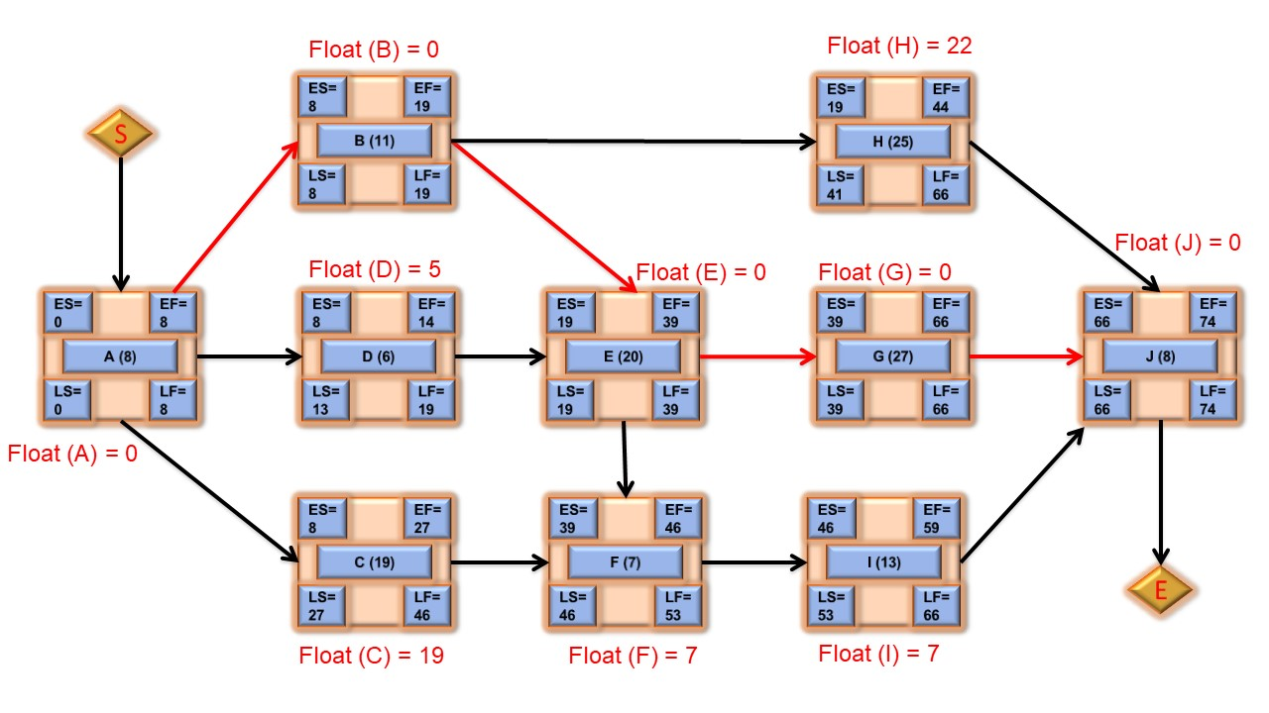

Float (A) = 0 Float (E) = 0 Float (I) = 7

Float (B) = 0 Float (F) = 7 Float (J) = 0

Float (C) = 19 Float (G) = 0

Float (D) = 5 Float (H) =22

1. What is the timeline within which the project can earliest be completed and explain why you say so? (1 points)

Ans : The earliest timeline within which project can be completed is **74** days, because the critical path calculated for the project is 74.

1. If D takes 4 days, what will be the impact to the project and the critical path? Explain your reasoning. (1 points)

Ans : If D takes 4 days, there will be no impact on critical path and project timeline, but now D will have more float time (7 days) and its ES = 8, EF = 12, LS = 15, LF = 19

1. If G takes an additional 7 days, what will be the impact to the project and the critical path? Explain your reasoning. (1 points)

Ans: If G takes additional 7 days, critical path and project timeline will increase by 7 days i.e. new critical path will be 81 days. Thus, earliest timeline of the project will be 81 days. This is because G is the part of critical path.